Blog: Pattie

Central California

We love visiting Central California because it gives us a beautiful mix of the ocean, the mountains, and farm life. It offers some of the best wineries on the West Coast, has little-known towns, and features fun little eateries sprinkled throughout the coast. Now that summer is coming up, we’ve started planning our next family road trip up to Central California, and it includes a handful of adventure-filled stops. The Central Valley and the Central Coast are where we’ll be spending the majority of our time because they’re both just a short drive away from Los Angeles. Want to plan your own Central California road trip and need ideas? Read on for our three-day family road trip itinerary!

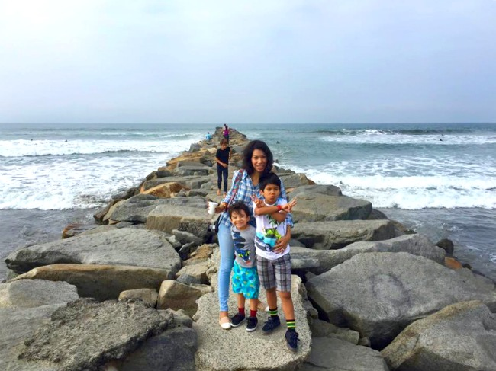

**Day 1 – Santa Barbara**

Closest to Los Angeles is the beautiful city of Santa Barbara. You’ll find this historic spot about an hour and a half north of L.A. Santa Barbara is known for its shopping, dining, and gorgeous scenery. This city is a big hit for multi-generational groups because it offers a lot of activities, including the Old Mission Santa Barbara, the Santa Barbara Zoo, and museums with a heavy emphasis on nature and history. And of course, the beach is always a hit too.

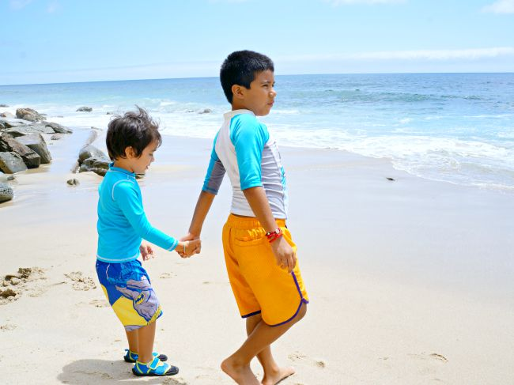

**You can find us at:** the Farmers Market in Downtown Santa Barbara on Tuesdays and Saturdays. There’s plenty of locally grown produce, along with an array of restaurants offering everything from pizza to tacos, served alongside some of the best wine in the state of California.

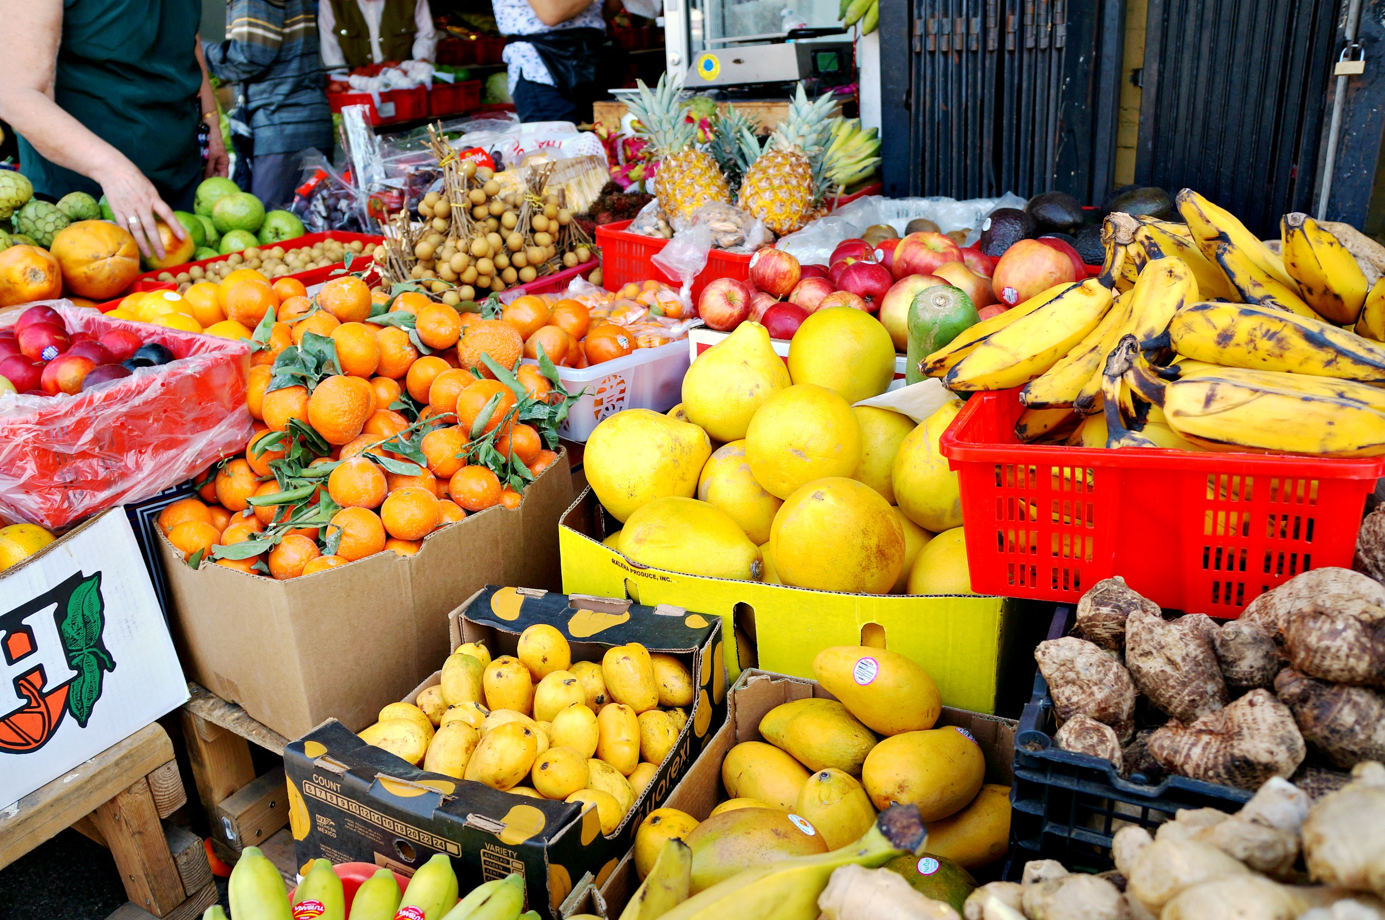

**Day 2 – Solvang**

About an hour away from Santa Barbara is a quaint little town called Solvang. Driving into Solvang will make you feel as though you’re stepping back in time. You will immediately get the small-town feel (it has a population of about 5,500) as you drive down its one major road and past its mom-and-pop shops and well-known bakeries. Founded by a group of Danes in 1911, the town gives you the feeling that it hasn’t changed much since then.

Solvang is still home to bakeries, restaurants, and merchants who have continued to offer a taste of [Denmark](https://en.wikipedia.org/wiki/Denmark) through its food, landscape, and museums.

**You can find us at:** the shoe store trying on a pair of clogs, the local bookstore peeking into the [Hans Christian Andersen](https://en.wikipedia.org/wiki/Hans_Christian_Andersen) museum upstairs, and, of course, around Copenhagen replicas like the Little Mermaid statue and the Round Tower, taking family pictures. We’ll also be stopping by Old Mission Santa Inés near the center of town. Just outside of Solvang, we’ll stop by OstrichLand USA—a ranch where visitors can see ostriches, feed them, and even buy their eggs!

**Day 3 – Central Valley**

Covering a large piece of California is the Central Valley. This area is known for producing an abundance of fresh fruits, vegetables, and greenery, coupled with its small-town feel and country atmosphere. Highway 99 will take you where you need to go, but your family will enjoy discovering off-the-beaten-path destinations the most.

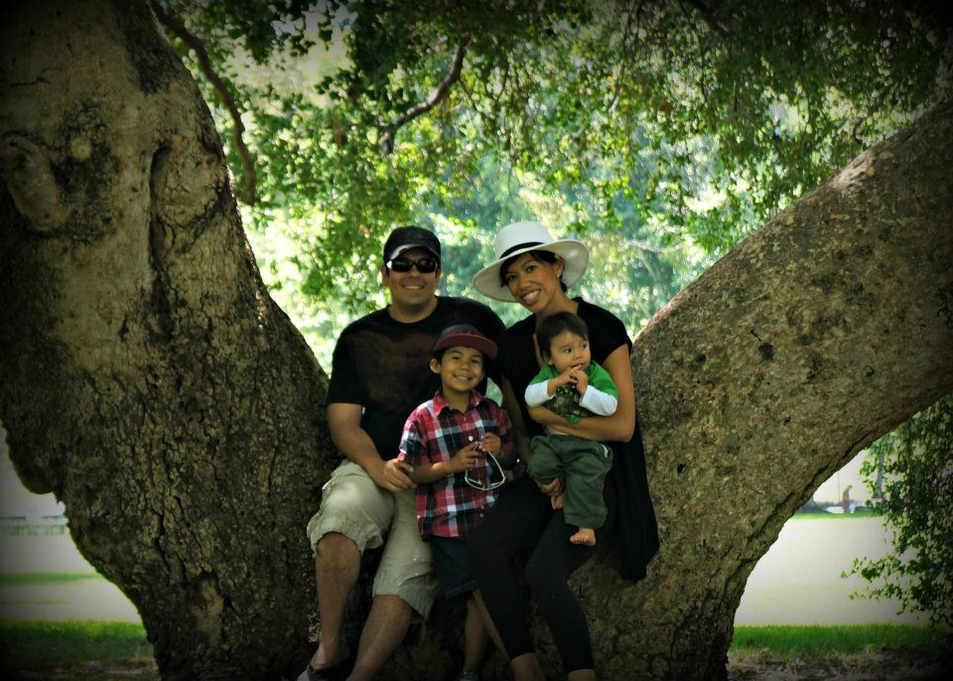

**You can find us at:** the produce stands, stocking up on in-season fruits. We’d like to visit UC Davis and rent bikes to discover the campus, and maybe take some time for some much-needed water play at The Delta. There, you can do everything from waterskiing to fishing to wildlife watching.

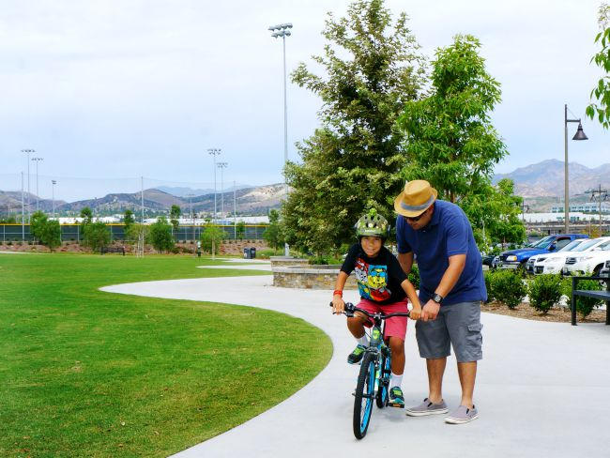

Central California is a wonderful region of the Golden State, with the ocean and mountains surrounding the family-owned farms and quaint towns that you’ll run into simply by driving down the scenic highways. Families can always find something that they enjoy doing. Whether we choose a day at the beach, a tour of historic missions, or fruit picking at a farm, Central California will give us three days of fun, great meals, and bonding moments that will carry us into our future California travels.

